# SHEET -5 – I/O REDIRECT,

## I/O Redirect Redirecting standard o/p and error

1. Create a file called output.txt that contains the output of the date command

Note : run date cmd in the terminal and observe the o/p

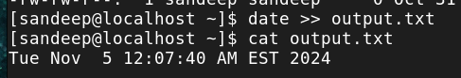

1. Append the current user’s name to a file called output.txt ( use whoami)

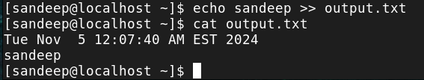

1. Append the host name to a file called output.txt ( use hostname)

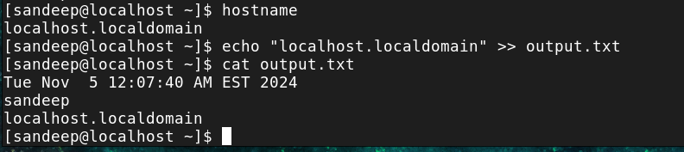

1. Attempt to list a non-existent directory and redirect the error message to error.log
2. Run a cmd to get output and error and redirect only the output to file and display the error
   1. Use ls -l existingdir non-existentdir → e.g. ls -l CEO dir1 2>&1 > error.log ls cat ou
   2. Cat existingfile non-existentfile



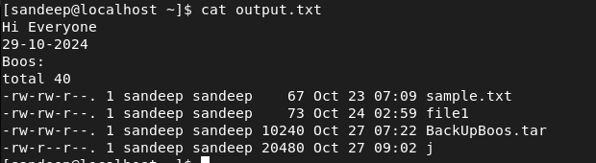

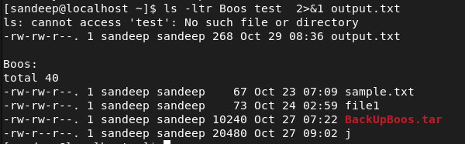

1. Run a cmd to get output and error and redirect only the error to file and display the output
   1. Use ls -l existingdir non-existentdir → e.g. ls -l CEO dir1 2>error.log
   2. Cat existingfile non-existentfile

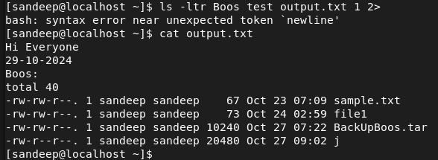

1. Run a cmd to get output and error and redirect both to combined.txt
   1. Use ls -l existingdir non-existentdir → e.g. ls -l CEO dir1 > combined.txt 2>&1
   2. b. Cat existingfile non-existentfile

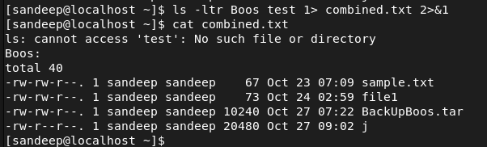

## Redirecting standard i/p

1. Create a file with numbers. Read the file using cat cmd .



1. Read the same file using cat and i/p redirect e.g cat < file.txt



1. Read the file /etc/passwd file and display only last 4 lines using i/p redirect and o/p to a file **Filters or**

